MODERN WORK OPPORTUNITY PLATFORM
Software Requirements Specification

Version 1.0



Group Id: F230233010
Supervisor Name: Muhammad Qamar Usman

Revision History
Date (dd/mm/yyyy) | Version | Description | Author
6/12/2023 | 1.0 | The goal of this Job Portal System is to make the job search and hiring process easier for candidates and employers.These tasks will be handled through Secure Login and Registration for both Job Seeker and Employer. | BC210426298  Ishrat Fatima  MC220203364
 |  |  | Tahira

Table of Contents

- Scope (of the project)
- Functional Requirements Non Functional requirements
- Use Case Diagram
- Usage Scenarios
- Adopted Methodology
- Work Plan (Use MS Project to create Schedule/Work Plan)

SRS Document

Scope of Project:

The objective of the proposed project is to create an end-to-end Job Portal System, an easy-to-use online platform that connects job seekers with employers.The Job Portal will make it easier for job seekers to create profiles, search for jobs,and apply for jobs. Job seekers will be able to easily find jobs, post job vacancies, andreview applications, while employers will be able to efficiently manage their hiring process.The goal of this Job Portal System is to make the job search and hiring process easier for candidates and employers.These tasks will be handled through Secure Login and Registration for both Job Seeker and Employer. Employers can easily post, edit and remove job listings. Job Seeker can easily search and view job information without registration. Job Seeker has advanced search options such as Keyword Search and Filters. Jod Seeker profiles can be created and managed by Job Seeker, including Personal Information, Skills, Education, and Work Experience. Company profiles can be created by Employer, showing their mission, Values, and Job Opportunities. Job Applicants can apply for Jobs with a click, Attach Their Resume and Cover Letter. Employer can view Applications, Shortlist Candidates, Schedule Interviews.
In addition, there will be a dedicated Admin Pannel, which will include a dashboard for administrators, to manage the platform’s operations. This dashboard will also allow administrators to manage user, job listing, and reporting capabilities.The web application will use PHP as a backend, and HTML5/CSS/Javascript/Bootstrap for a responsive and easy-to-use user interface as the frontend.The database will use MYSQL to store and retrieve data efficiently.

Functional and non Functional Requirements:

FUNCTIONAL REQUIRMENTS: -
There are mainly two stakeholders/actors of this project those are Admin and Tenants and each actor has its own different functional requirements
Functional Requirements:
- Authentication of the User: The system should provide secure login and registration for job seekers and employers. There should be password recovery mechanisms for forgotten passwords.
- Admin Dashboard: The system should provide a dashboard for administrators to oversee the platform's activity.
- Profiles: Job seekers can create and manage their profiles, including personal information, skills, education, and work experience. Employers can also create and manage their company profiles, showcasing their mission, values, and job opportunities.
- Jobs / Job Search Facility: Employers can post, edit, and remove job listings with ease. Job seekers can search and view job details without registration. Advanced search options for job seekers, including keyword search and filters.
- Application Management Dashboard: Job seekers can apply for jobs with a click, attaching their resumes and cover letters. Employers can view applications, shortlist candidates, and schedule interviews. Automated email notifications for application status updates.
- Resume Builder: Provide a tool for users to create and edit professional resumes directly on the platform.
- User Reviews and Ratings: Allow employers and job seekers to leave reviews and ratings for each other based on their interactions and experiences.
- Notifications and Alerts: Send email or SMS notifications to users for job matches, application status updates, and other relevant activities.
- Analytics and Reporting: Generate reports on user engagement, job posting statistics, and application trends to analyze the platform's performance.
- Integration with social media: Allow users to sign in or share job listings via social media platforms to increase visibility and user engagement.
- Feedback Mechanism: Implement a feedback system in the project to collect user opinions and suggestions for continuous improvement of the platform.

NON-FUNCTIONAL REQUIREMENTS
Usability:
Usability of the software can be easy so that the user can use it easily without any difficulty
Maintainability:
Software should be built up in such a way that classification of errors and maintains of application becomes easy
Operating System:
Software should be able to run on all type of operating systems like Windows XP, Window 7 and others.
Some of the others are:
Accessibility
Security
Actors:
The system consists of three main modules as follows:
Admin
Job Seeker
Employers

Tools: PHP, MySQL, VsCode, Google Chrome , Notepad++ etc.
Application Type: Web based Application
Use Case Diagram(s):
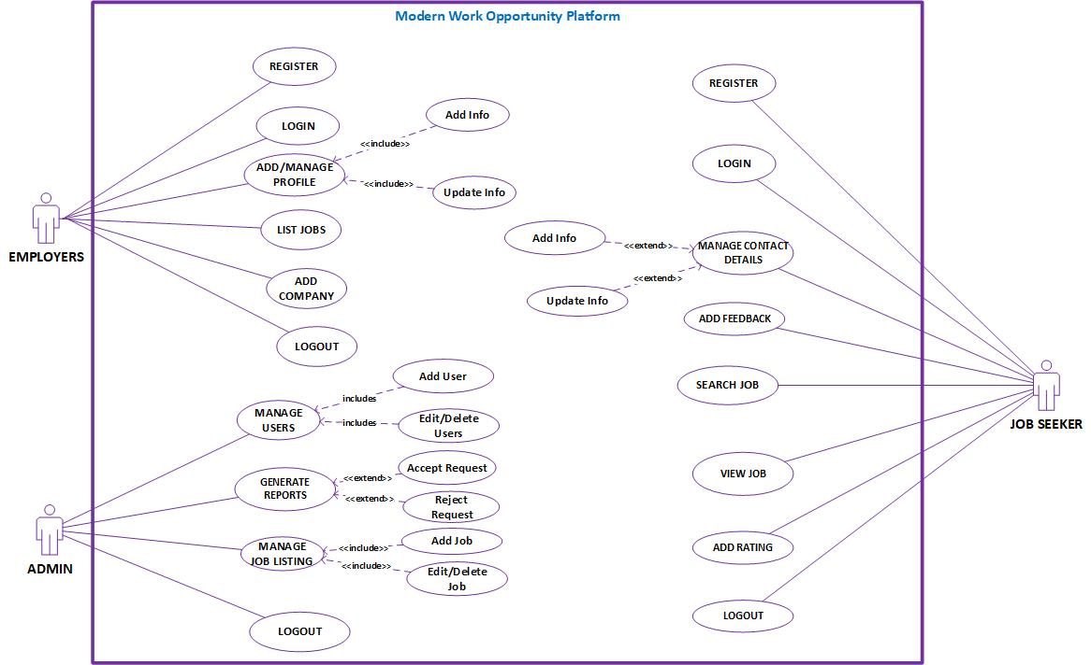

USAGE SCENARIOS:
REGISTER:

Use Case id | 1
Use Case title | REGISTER
Description | All employers/Job Seeker who wants to use this system must have to register themselves on this website.
Pre-condition | Application interface must be available.
Action | - Open application interface of create account  - Fill the form of registration  - Click on “Register” button to get registered
Post Conditions | Employers/Job Seeker successfully created in database.
Alternative Path: | Employers/Job Seeker may not want to register this time
Exception: | If the user entered invalid data in the form then the exception occurs “Fill mandatory Fields”
Authority | Employers/Job Seeker
Author

LOGIN:

Use Case id | 2
Use Case title | LOGIN
Description | All stakeholders/Actors of the website must have to login to use some key features of this website.
Pre-condition | Actors must be registered with our website , Application interface must be available
Action | - Open application interface of login  - Enter user name and password  - Click on “Login” button
Post Conditions | Actors successfully login and able to further work
Alternative Path: | Actors may not want to login this time
Exception: | If the user entered invalid data in the form then the exception occurs “Invalid user name and password”
Authority | Employers , Job Seeker, Admin
Author

ADD PROFILE:

Use Case id | 3
Use Case title | ADD PROFILE
Description | This use case allows employers and job seeker of the system to maintain their profile which is later on available on our website for job seekers and employers and vice versa.
Pre-condition | Employer user of the system must be registered with our website and logged in.
Action | - Login as Employer  - Fill add profile form  - Click on “Update Profile” button
Post Conditions | Profile successfully updated and available to job seekers and employers and vice versa
Alternative Path: | -
Exception: | If the user entered invalid data in the form then the exception occurs “Please enter correct and valid data”
Authority | Employer, Job Seeker
Author

ADD JOB:

Use Case id | 4
Use Case title | ADD JOB
Description | This use case allows admin and employers of the system to add job listing which is later on available on our website for job seekers.
Pre-condition | Admin and Employers user of the system must be registered with our website and logged in.
Action | - Login as Admin Or Employers  - Fill add room form  - Click on “Add Job” button
Post Conditions | Job successfully added and available on our website for job seekers.
Alternative Path: | -
Exception: | If the user entered invalid data in the form then the exception occurs “Please enter correct and valid data”
Authority | Admin and Employers
Author

ADD COMPANY:

Use Case id | 5
Use Case title | ADD COMPANY
Description | This use case allows employers of the system to add company which is later on available on our website for job seekers.
Pre-condition | Application interface must be available. And system must be logged in as Employer
Action | - Open application interface of create account  - Fill the form of add company  - Click on “Add Company” button to get registered
Post Conditions | Company successfully created in database.
Alternative Path: | Employer may not want to add company this time
Exception: | If the user entered invalid data in the form then the exception occurs “Fill mandatory Fields”
Authority | Employer
Author

MANAGE USERS:

Use Case id | 6
Use Case title | MANAGE USERS
Description | This usecase allows admin user of the system to manage all skakeholders i.e Job Seeker , Employers registered on website any time
Pre-condition | Application interface must be available. And system must be logged in as Admin
Action | - Open application interface of create account  - View manage_user.php page  - Select Particular user to manage  - Perform your desired actions
Post Conditions | Upated information added in database.
Alternative Path: | Admin may not want to manage user this
Exception: | If the user entered invalid data in the form then the exception occurs “Fill mandatory Fields”
Authority | Admin
Author

GENERATE REPORTS:

Use Case id | 7
Use Case title | GENERATE REPORTS
Description | This use case is about generating different reports of our system
Pre-condition | Application interface must be available. And system must be logged in as Admin
Action | - Open application interface of create account  - Click on “View Reports” button  - Select Your desired report i.e monthly daily etc
Post Conditions | Employee successfully created in database.
Alternative Path: | -
Exception: | If user is not admin this will not work
Authority | Admin
Author

MANAGE JOB:

Use Case id | 8
Use Case title | MANAGE JOB
Description | This usecase allows admin user of the system to manage all jobs added by Employers or Admin.
Pre-condition | Application interface must be available. And system must be logged in as Admin or Employer
Action | - Open application interface of create account  - View manage_jobs.php page  - Select Particular Job to manage  - Perform your desired actions
Post Conditions | Upated information added in database.
Alternative Path: | Admin or Employer may not want to manage job this time
Exception: | If invalid data entered in the form then the exception occurs “Fill mandatory Fields”
Authority | Admin or Employer
Author

ADD FEEDBACK:

Use Case id | 9
Use Case title | ADD FEEDBACK
Description | This use case is about adding/giving feedback from customers
Pre-condition | Application interface must be available. And system must be logged in as Job Seeker
Action | - Open application interface and select particular employer  - Fill Add Feedback Form  - Submit your feedback
Post Conditions | Feedback submitted and send to that particular Employer
Alternative Path: | -
Exception: | -
Authority | Job Seeker
Author

SEARCH JOB:

Use Case id | 10
Use Case title | SEARCH JOB
Description | This use case allows job seekers to view/search the desired Job available on our system
Pre-condition | Application interface must be available
Action | - Open application interface and fill the criteria of search job.  - Click on the “SEARCH” button
Post Conditions | All jobs that fall on the search criteria will be displayed on the website
Alternative Path: | Job Seeker may not want to search job this time
Exception: | If none of the room or flat is available in the database no item will be displayed.
Authority | Job Seeker
Author

ADD RATING:

Use Case id | 11
Use Case title | ADD RATING:
Description | This use case is about adding/giving rating to Employers
Pre-condition | Application interface must be available. And system must be logged in as Job Seeker
Action | - Open application interface and select particular employer  - Give Rating Through Star rating  - Submit your Rating
Post Conditions | Rating submitted and send to that particular Employer
Alternative Path: | -
Exception: | -
Authority | Job Seeker
Author

LOGOUT

Use Case id | 12
Use Case title | LOGOUT
Description | This use case allows all the actors of the system to logout from website.
Pre-condition | The application interface must be available and any of the actor must be Logged in.
Action | - Open application interface.  - Click on Logout Button.
Post Conditions | Session is destroyed and actor will be logout from system.
Alternative Path: | Force close website.
Exception: | If session is empty than this feature is not available.
Authority | Admin,Job Seeker , Employer
Author

Adopted Methodology
Development of any software product or application choice of right model is very important. The selection of model has very high impact on the testing that is carried out. It will define that what, where and when of our planned testing, influence regression testing and which test techniques to use. The development models are the various processes or methodologies that are being selected for the development of the project depending on the project aims and goals. There are many development life cycle models that have been developed in order to achieve different required objectives. The models specify the various stages of the process and the order in which they are carried out There are various Software development models or methodologies we discus Water Fall and Spiral Model in the following.

Waterfall Model:
The waterfall Model is a linear sequential flow. In which progress is seen as flowing steadily downwards (like a waterfall) through the phases of software implementation. This means that any phase in the development process begins only if the previous phase is complete. The waterfall approach does not define the process to go back to the previous phase to handle changes in requirement. The waterfall approach is the earliest approach that was used for software development.
Diagram
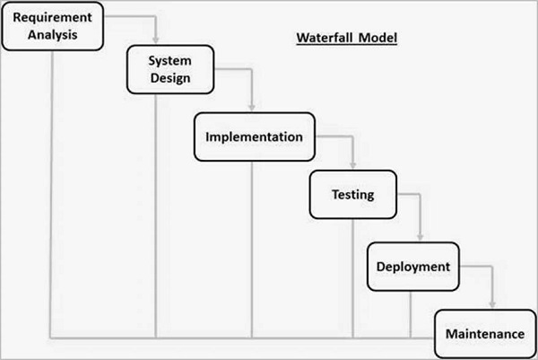
Spiral Model:
The spiral model is similar to the incremental model, with more emphasis placed on risk analysis. The spiral model has four phases: Planning, Risk Analysis, Engineering and Evaluation. A software project repeatedly passes through these phases in iterations (called Spirals in this model). The baseline spiral, starting in the planning phase, requirements are gathered and risk is assessed. Each subsequent spirals builds on the baseline spiral.
Planning Phase:
Requirements are gathered during the planning phase.
Risk Analysis:
A prototype is produced at the end of the risk analysis phase. If any risk is found during the risk analysis, then alternate solutions are suggested and implemented.
Engineering Phase:
In this phase software is developed, along with testing at the end of the phase. In this phase the development and testing is done.
Evaluation phase:
This phase allows the customer to evaluate the output of the project to date before the project continues to the next spiral.
Diagram of Spiral model:
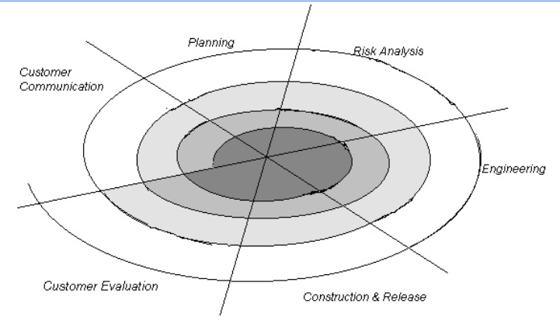
VU Process Model:
The methodology chosen for this project is VU Process Model. The vu process model, offers numerous advantages for software developers and because of its beneficial flow I use this methodology. This model is a combination of Waterfall and Coiled/Spiral Model. This is a hybrid approach of system development, which maximizes the quality of system and minimizes the disadvantages and risks.
VU process model has four phases; each phase is tested on its completion. It
conserves resources and is superlative for sustaining less skilled plan teams and project managers whose composition fluctuates. The errors are removed due to iteration to previous or next phases. The orderly sequence of development steps and strict controls for ensuring the adequacy of documentation and design reviews helps ensure the quality, reliability, and maintainability of the developed software. The progress of system development is measurable.VU Process model depicts the linear nature of waterfall and iterative risk analysis of spiral. We analyze each phase activity with the end product. VU Process model will help us in identification of risk at the time as it omits. So resolution of that risk will be much easy at that point, while if it is detected at later stage then the resolution will become much more painful and costly (time& budget). Also documentation makes the maintenance of product after its delivery easy. So by combining the spiral & waterfall we get the benefits of waterfall and risk sensitivity of the spiral.
REASONS FOR CHOOSING THE METHODOLOGY
- The Waterfall Model is a documentation-driven model. It therefore generates complete and comprehensive documentation and hence makes the maintenance task much easier. Documentation helps to keep track to risk.

- It suggests a systematic, sequential approach to software development that begins at the system level and progresses through the analysis, design, coding, testing, and maintenance.
Vu Process Model Diagram;
Analyzing & Gathering requirement

Planning Phase

Analysis & Design Phase

Development Phase

Operation & Maintenance
Analysis and Design Phase
Development Phase
Operation & Maintenance

Work Plan (Use MS Project to create Schedule/Work Plan)

SRS AND DESIGN DOCUMENT

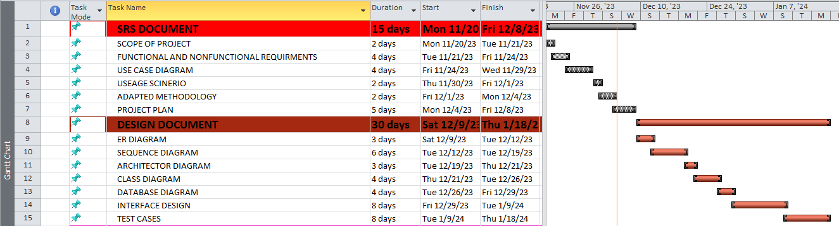

TESTPHASE AND FINAL DELIVERABLES

